1. Introduction
Google Sites
Google Sites is a free website-building tool provided by Google. It allows users to create simple and professional websites without requiring any programming or web design skills. Google Sites is widely used for creating educational websites, lab reports, project pages, portfolios, and internal organizational sites. It is integrated with other Google services such as Google Drive, Google Docs, Google Slides, and Google Forms, which makes content management easy and efficient. Users can create, edit, and publish websites directly from a web browser.

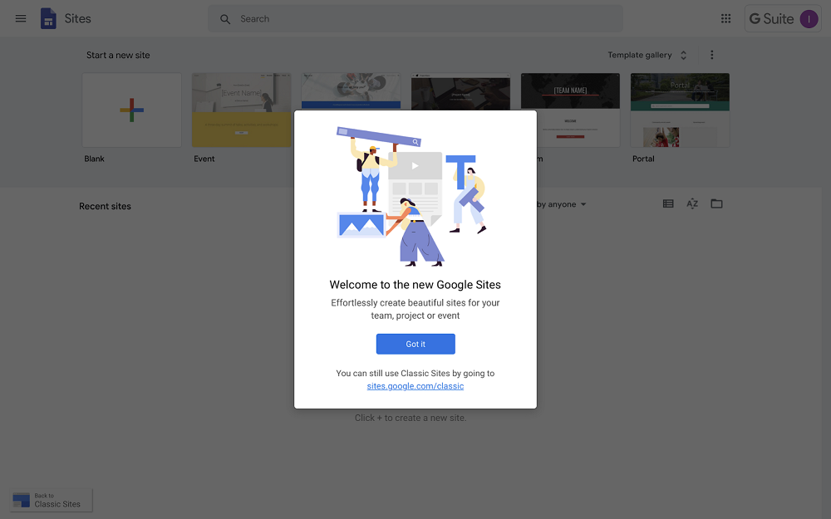

Google Sites Features
- Google Sites comes with a host of useful features, including:
- Google Sites templates with responsive design across devices
- Themes that give a coherent, designed look
- The ability to embed Youtube videos, images, and other content
- Tables of contents and expandable text for easy overview
- Integration with other Google Workplace tools:
- Add documents or sheets (Google Docs and Google Sheets)
- Display forms (Google Forms)
- Add map (Google Maps)
- Show calendar (Google Calendar)
- Tool for embedding code to the pages
- User access and visibility management
The Benefits of Google Sites
- Free to use
- Intuitive tools that let you get started in minutes, without installing or downloading any software
- You can access Google Sites anywhere and from any device
- Integrated with other Google Workplace tools such as Google Docs, Google Calendar, and Google Maps
- Easy to edit and manage access

2.Tools of Google Sites
- Creating a New Google Site
Google Sites allows users to create a new website quickly. Users can start with a blank site or choose from pre-designed templates. The creation process is simple and requires only a Google account.
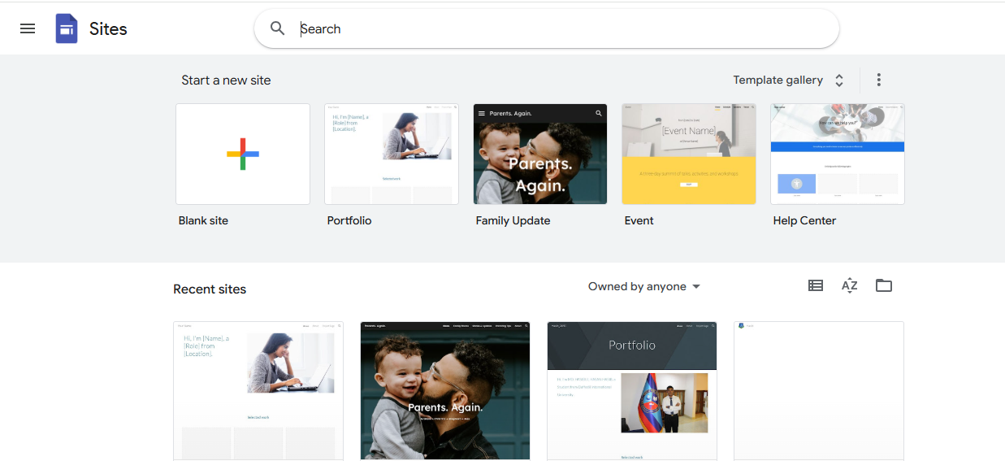
Steps:
- Open Google Sites
- Click on the Blank or any template
- A new editable site opens automatically
Use: Helps users start building a website easily.
- Google Sites Interface
The Google Sites interface is user-friendly and designed for easy website creation. It includes a Header Area to display the site title and banner, an Insert Panel to add content like text, images, and videos, a Pages Panel to manage and organize different pages of the site, and a Themes Panel to customize the site’s design and style. The Top Toolbar provides options to preview, share, and publish the site. Overall, the interface allows users to build and manage websites efficiently without requiring coding skills.
Main Parts of the Interface:
- Header Area – Displays site title and banner
- Insert Panel – Used to add content
- Pages Panel – Used to manage pages
- Themes Panel – Used to change design and style
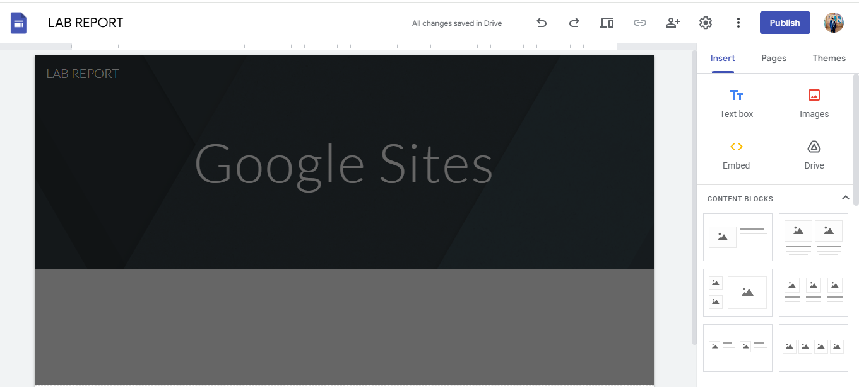
- Top Toolbar – Contains preview, share, and publish options
Name of the site which to be saved in your google drive
Name of the site which to be displayed on the internet
Preview
This is the work space where you can add different feature form the pallet
Place your page title here
Feature pallet to drag and drop stuffs to design page

- Insert Tools
The Insert Tools in Google Sites allow users to add various types of content to their web pages. You can insert Text Boxes for writing content, Images from your computer or the web, Embed URLs or code, YouTube videos, Google Drive files (Docs, Sheets, Slides, etc.), and Buttons or Dividers to organize content. These tools make it easy to customize pages and present information in a clear and interactive way.
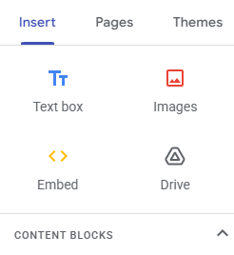

Features of Insert Tools and their uses
a) Text Box
The Text Box tool allows users to add written content such as descriptions, headings, and paragraphs.
Use:
Used to explain topics, write instructions, and add information.
b) Images
The Images tool allows users to upload images from a computer, Google Drive, or the web.
Use:
Used to add screenshots, diagrams, and photos to make the site more attractive and understandable.
c) Drive
The Drive option allows users to insert files directly from Google Drive such as Docs, Slides, Sheets, and Forms.
Use:
Helpful for embedding reports, presentations, and forms.
d) Embed
The Embed tool allows users to add content using a URL or embed code.
Use:
Used to embed videos, maps, charts, or external websites.
e) Layouts
Layouts provide pre-designed structures to arrange text and images neatly.
Use:
Helps maintain a clean and organized website design.

- Pages Features
The Pages Feature in Google Sites allows users to create, manage, and organize different pages of a website. You can add new pages, reorder pages, nest pages under other pages to create subpages, and rename or delete pages as needed. This feature helps structure the website, making navigation simple and intuitive for visitors.

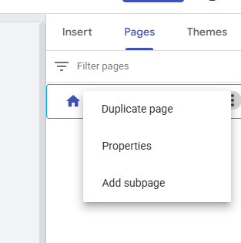
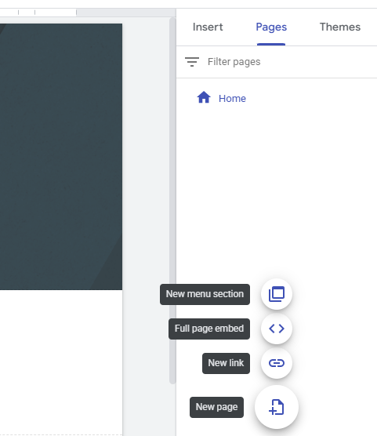

Functions:
- Add new pages
- Create subpages
- Rename or delete pages
Use:
Helps organize content in a structured manner.

- Theme
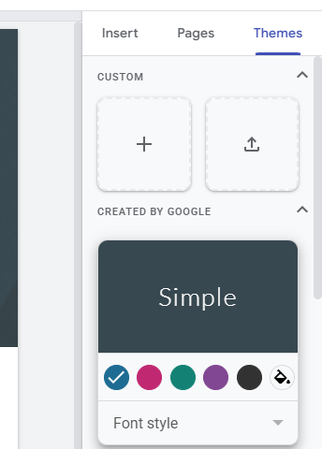
The Themes Feature in Google Sites allows users to customize the overall design and appearance of their website. You can choose from a variety of pre-designed themes, adjust colors, fonts, and styles, and apply them consistently across all pages. This feature ensures a professional and visually appealing look, making the website more attractive and easier to navigate for visitors.
Import Theme
Custom Theme

Features:
- Change font style
- Change color scheme
- Apply consistent design
Use:
Makes the website visually attractive and professional.

- Preview Option
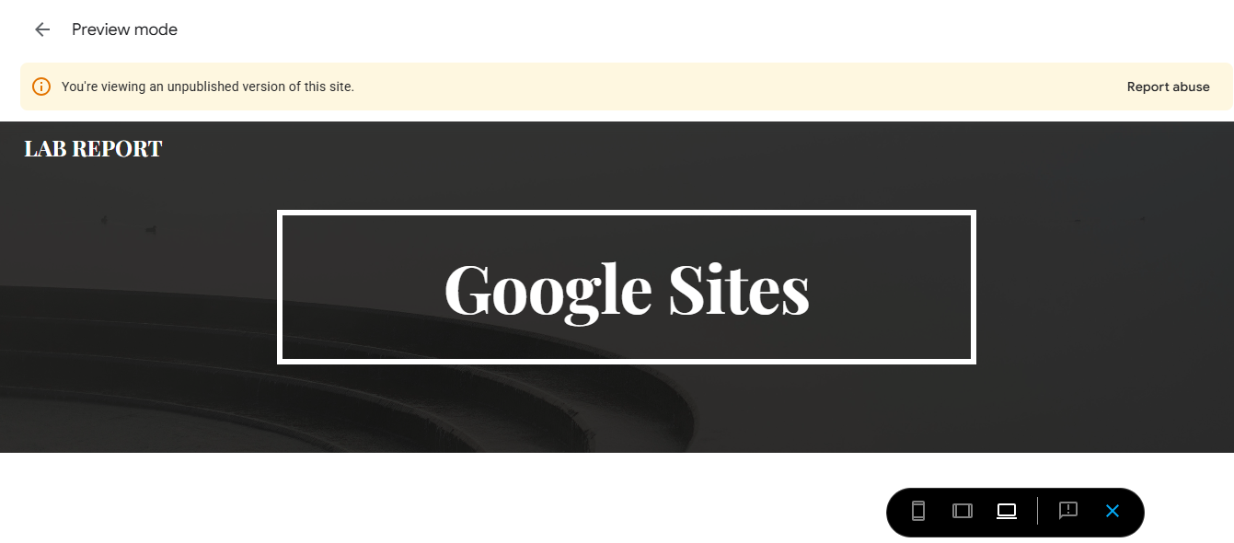
The Preview option in Google Sites allows you to see how your website will appear to visitors before publishing it. By clicking the Preview button, you can view your site in different device modes, such as desktop, tablet, and mobile, ensuring that the layout, text, images, and other elements are displayed correctly on all screens. This feature helps you check the design, alignment, and overall user experience, so you can make adjustments if needed before making your site public.
Preview Modes:
- Desktop
- Tablet
- Mobile
Use:
Helps ensure the website looks good on all screen sizes.
- Share and Permissions
The Share and Permissions feature in Google Sites allows you to control who can view or edit your website. By clicking this option, you can invite specific people via their email addresses and assign them different roles, such as Viewer (can only see the site) or Editor (can make changes to the site). You can also set your site’s visibility to the public, anyone with the link, or restrict it to specific people. This feature ensures your website is shared safely and only with the intended audience.
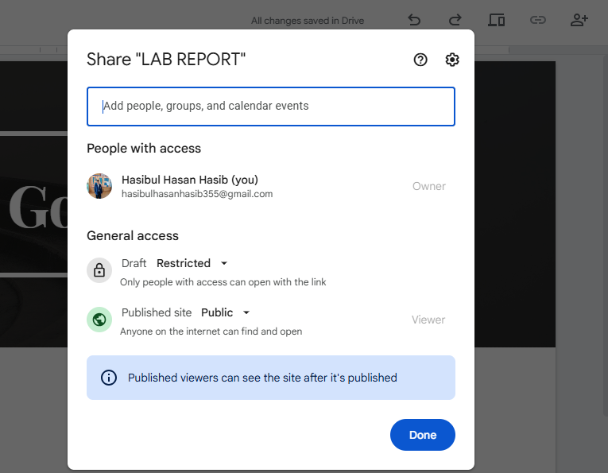
Permission Types:
Share
- Viewer
- Editor
Use:
Ensures secure collaboration and controlled access.
H. Publish
The Publish option in Google Sites allows you to make your website live on the internet so that others can access it. By clicking the Publish button, you can choose a web address (URL) for your site and decide who can view it—either the public, anyone with the link, or specific people. Once published, your site is accessible to visitors, and any updates you make can be republished to reflect the latest changes. This feature is essential for sharing your work and making your website officially available online.
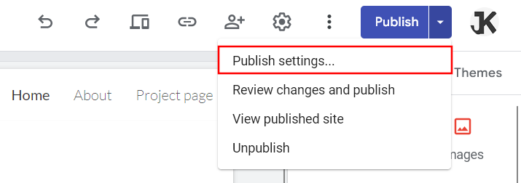
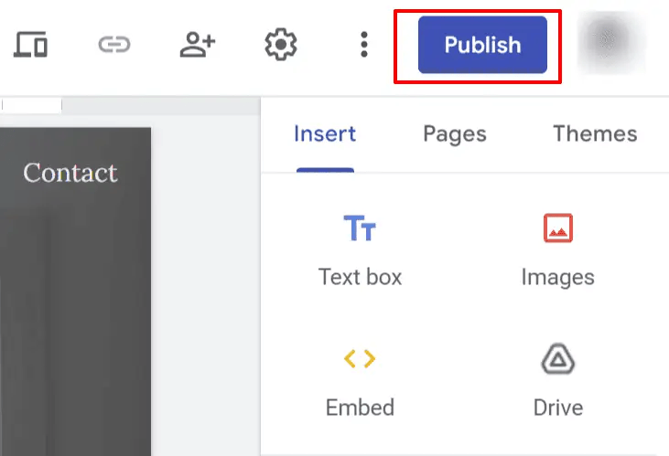
[Grab your reader’s attention with a great quote from the document or use this space to emphasize a key point. To place this text box anywhere on the page, just drag it.]
Steps:
- Click the Publish button
- Enter web address
- Set visibility options
- Click Publish
Use:
Allows others to access the website online.
I. Editing and Updating Site
The Editing and Updating feature in Google Sites allows you to make changes to your website even after it has been published. You can add or remove content, modify text, insert images, videos, or other elements, and adjust the layout as needed. After making updates, you can republish the site to ensure that visitors see the latest version. This feature ensures that your website stays current, accurate, and visually appealing over time.
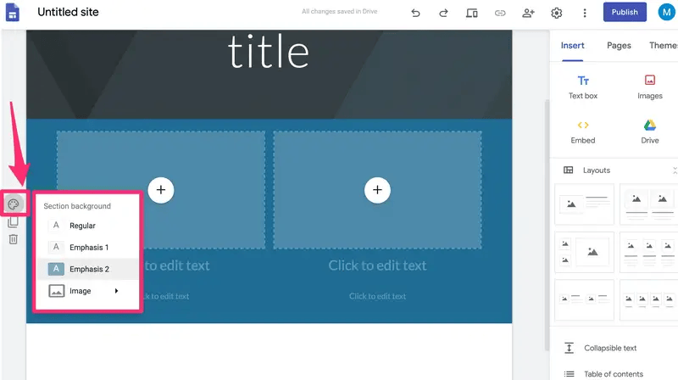
J. Conclusion
Google Sites is a powerful yet easy-to-use website creation tool. It helps users create professional websites without any coding knowledge. With features like Insert tools, Pages, Themes, Preview, and Publish options, users can design well-organized and attractive websites. Integration with Google Drive makes content management efficient. Therefore, Google Sites is an excellent platform for students, teachers, and professionals to create educational and project-based websites.

